[**10 Key features in IIB V 10**](https://eaideveloper.wordpress.com/2016/03/29/ten-key-features-in-iib-v-10/)

Posted on [March 29, 2016](https://eaideveloper.wordpress.com/2016/03/29/ten-key-features-in-iib-v-10/)by [vishnu](https://eaideveloper.wordpress.com/author/vishnurajnr/)

IBM Integration Bus V10 was released quite some time from now. IIB V10 is the second release of Integration Bus family after Websphere message broker is re branded as IBM integration Bus. The new release is having some popular new features. Popular in the sense, these features were demanded over communities or RFEs.

I would like to write the 10 new features which I like the most from IIB V10 in this post. These are my personal choice and I would not say these are the only key features in IIB V10.

**1. Removal of the WebSphere MQ prerequisite**

This is one of the strategical move to decouple two IBM products. Like few other vendor ESB products, messaging engine is not tightly coupled with the ESB. This can be a nice feature where an organization is not using IBM MQ for their MOM, but heavily uses Webservices or other protocols.

*WebSphere MQ is no longer a prerequisite for using IBM Integration Bus on distributed platforms, which means that you can develop and deploy applications independently of WebSphere MQ. You can also run and administer integration nodes without requiring the WebSphere MQ Explorer.*

*When you purchase a license for IBM Integration Bus, your license entitles you to install and use WebSphere MQ with IBM Integration Bus, enabling you to use the IBM Integration Bus capabilities that require MQ functionality, such as the MQ nodes and event driven processing capabilities such as message aggregation and sequencing.  
For more information about using WebSphere MQ with IBM Integration Bus, see*[*Enhanced flexibility in interactions with WebSphere MQ*](https://www.ibm.com/support/knowledgecenter/SSMKHH_10.0.0/com.ibm.etools.mft.doc/bb28660_.htm?lang=en)

But definitly there is a trade off when there is No IBM MQ with IIB. Few are listed below:

*The following IBM Integration Bus features require WebSphere MQ Server to be installed on the same machine as the integration node, and they are available for use only if you specify a queue manager on the integration node:*

*Record and replay  
Global transactionality  
Event-driven processing nodes (aggregate, collector, sequence, resequence, and timeout nodes)  
FTEInput and FTEOutput nodes  
CDInput and CDOutput nodes  
SCA nodes (with MQ bindings)  
Integration nodes with HTTP listeners  
HTTP proxy servlet  
High availability configurations*

**2. Shared libraries**

Applications and Libraries were one of the key feature in WMB V8 release. Though Libraries are designed to isolate common reusable objects, but when it is using by an Application, application always take its own local copy. So this was not a common object when used by an Application. In IIB V10, we have shared Library to overcome this behavior. Libraries are now what it is originally designed for.

As Per InfoCenter:

*Shared libraries are introduced to share resources between multiple applications. Libraries in previous versions of IBM Integration Bus are static libraries.  
If you use a static library to contain resources, each application that references that static library is deployed with its own private copy of that library. If a static library is updated, each application that references it must be redeployed with the updated static library. A shared library is deployed directly to an integration server. Any application can reference the resources in that deployed shared library. If that shared library is updated, the changes are immediately visible to all referencing applications.*

**3. Test your message flows by using the Flow Exerciser**

This is one of the key feature in the Integration toolkit. Flow exerciser will help to trace the message flow path more easily.

To check that a message flow is processing messages as expected, you can send messages to the flow, see the path that each message took, and view the structure and content of the logical message tree at any point in a message flow.

Steps below will demonstrate this very briefly.

To start the flow exerciser, click the start recording on the flow exerciser tab:

[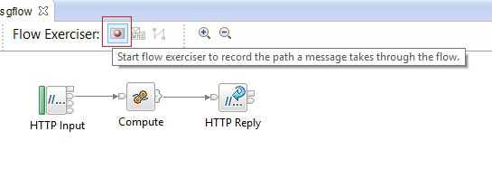](https://eaideveloper.files.wordpress.com/2016/03/flowexerciser_start.jpg)

This will deploy the flow integration bus and will give a prompt with details of capturing the message path.

[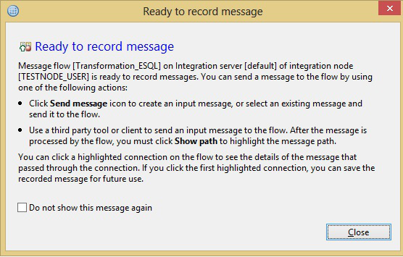](https://eaideveloper.files.wordpress.com/2016/03/flowexerciser_startrecording.jpg)

Once deployed, you can send a sample message to the flow and trace the message path:

[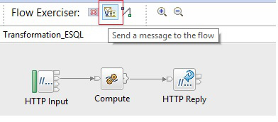](https://eaideveloper.files.wordpress.com/2016/03/flowexerciser_sendmessage.jpg)

[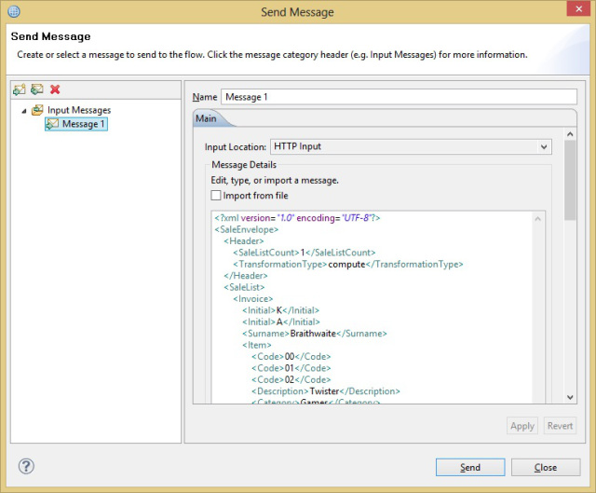](https://eaideveloper.files.wordpress.com/2016/03/flowexerciser_sendmessage2.jpg)

Once messages send and completed, the flow will highlight the message path on the flow:

[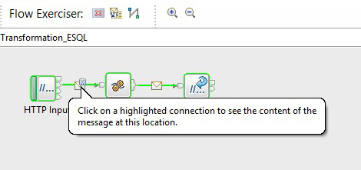](https://eaideveloper.files.wordpress.com/2016/03/flowexerciser_highlightmessage.jpg)

Click on the highlighted connection to see the message structure (Headers & Payload)

[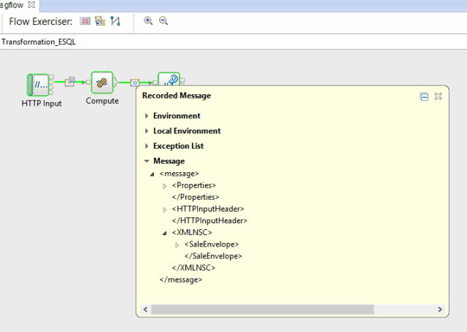](https://eaideveloper.files.wordpress.com/2016/03/flowexerciser_viewmessage.jpg)

Once done, you can stop the flow exerciser to stop recording the messages.

**4. mqsireportdbparms command**

You can return a list of parameters that are set on an integration node. In addition, you can use the mqsireportdbparms to check if security credentials are set, or identify if you are using the correct password for an integration node.

Details in [InfoCenter](https://www.ibm.com/support/knowledgecenter/SSMKHH_10.0.0/com.ibm.etools.mft.doc/an09156_.htm?lang=en)

**5. Fixed naming for DataDirect ODBC database drivers**

In previous IIB/WMB versions, data direct drivers will be installed on each fix pack and you need to manually update the driver path in odbc ini file each time when you install a fix pack.

ODBC database drivers now have a fixed naming convention, which means that you do not have to update links to drivers and switch files after you update to a later version.

Details: [here](https://www.ibm.com/support/knowledgecenter/SSMKHH_10.0.0/com.ibm.etools.mft.doc/bh23392_.htm?lang=en-us)

**6. Flexible interaction with WebSphere MQ**

*On distributed systems, support for WebSphere MQ has been extended, introducing greater flexibility in the interactions between IBM Integration Bus andWebSphere MQ. You can configure local or client connections to WebSphere MQ, enabling your integration nodes to get messages from or put messages to queues on any local or remote queue manager. On z/OS®, you can have MQ message flow nodes connect to different local queue managers, not just the queue manager that is specified on the integration node.  
You can specify a connection from an MQ node to a specific local or remote queue manager by using connection properties on the MQ node, including the destination queue manager name, host name, port, and channel. Alternatively, you can specify a queue manager on the integration node to be used for MQ processing that is required by flows in the integration node; the queue manager that you specify is then used for all message flow nodes that do not have queue manager connections explicitly defined or policies attached. For more information about policies, see Operational policy.  
You can also create message flows that contain multiple MQInput and MQOutput nodes, each of which can access different queue managers as specified in the node; this enables you to adapt your message flows to your existing WebSphere MQ topologies. For more information about local and client connections between WebSphere MQ and IBM Integration Bus, see Configuring connections to WebSphere MQ.*

**7. Flexible administration security**

*You can choose between two modes of authorization when you enable administration security on an integration node: file-based authorization (file mode) or queue-based authorization (mq mode). You can specify your chosen authorization mode by using the mqsichangeauthmode command. If you configure the integration node to use file mode, you can set file-based permissions for accessing integration nodes and resources. These permissions are set using themqsichangefileauth command. Alternatively, if you have installed WebSphere MQ and specified a queue manager on the integration node, you can control access to the integration node and its resources by setting permissions on WebSphere MQ authorization queues.*

**8. Using the Environment tree as input data to your transformations**

*In a message map, you can update, delete, or create data in the environment tree Variables folder. You can use the environment tree as input data to your transformations.*

Details:[here](https://www.ibm.com/support/knowledgecenter/SSMKHH_10.0.0/com.ibm.etools.mft.doc/sm12008_.htm?lang=en)

**9. Business transaction monitoring**

*Typically, a business transaction consists of several system-level transactions. When you monitor business transactions in IBM Integration Bus, you track and report the lifecycle of a payload message through an end-to-end enterprise transaction. To monitor business transactions, you create a business transaction monitoring definition in the web user interface.*

**10. Develop integration solutions by using REST APIs**

You can now use REST APIs to create your integration solutions.

For more information about REST APIs, see [Developing integration solutions by using REST APIs](https://www.ibm.com/support/knowledgecenter/SSMKHH_10.0.0/com.ibm.etools.mft.doc/bi12016_.htm?lang=en-us)